2025 NED BIOLOGY PRACTICAL MARKING KEY
SECTION A
Question 1
- Take two potted plants ¹ , one with leaves labelled A and another one without leaves labelled B
- Tie the polythene bag ¹ round the stem of both plants
- Leave the two set-ups in a sunny place.¹
- Collect ¹ and test ¹ any liquid which collects in the plastic bags with anhydrous copper sulphate or anhydrous cobalt chloride paper!.
- Water is collected in plastic bag labelled A¹ and not or less water is collected in set up B¹
- A change in colour of anhydrous copper sulphate/ anhydrous cobalt paper from blue to pink colour¹ indicates water the presence of water and not in plants without leaves¹

Question 2
- Work in pairs (1)
- Take the pulse rate by placing (1) three fingers firmly on your partner’s wrist.
- Do not press hard, shift the position of fingers until you feel (1) some movements against your fingers.
- count /take(1) the number of times you feel these beats in a minute
- Record them in a table.
- Ask your partner to run (1) round the classroom block/jump for a few minutes(1)
- count /take the pulse and record
- Then the student should run round the classroom block (1).
- Take/count the pulse again and record.
- Compare the pulse rate at rest to pulse rate after exercise (1).
- The pulse rate is lower at rest than after an exercise (1) physical activity/exercise has an effect on pulse rate (1)

SECTION B
3a.the measurement of the leaf should be within the range of 100mm to 150mm (1)
b.The drawing should depict a shape of a clear mango leaf,the labels should be three (4 marks)
c. magnification = length of drawing/length of specimen(1)
substitution (1)
correct presentation of magnification (1)
d.it has veins/ that transport water for photosynthesis.
Has thin lamina for easy penetration of sunlight
Has petiole that expose the leaf to sunlight for photosynthesis.

4.A. DRAWING OF AN ONION
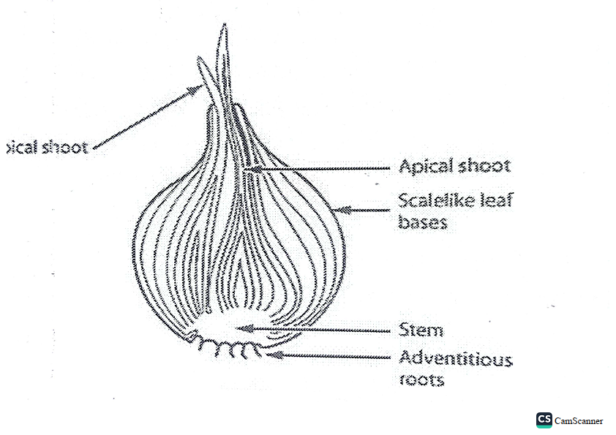
(1 Mark for Drawing)
(3 mark each for the 3 correct labelling)
b. Peel the specimen and cut a small piece (1) add iodine solution to the crushed pieces (1) starch will be present if it turns blue black color (1)
c. vitamins (1) dietary fibres (1) water (1) calcium (1)
THE END OF MARKING KEY

